Architecture
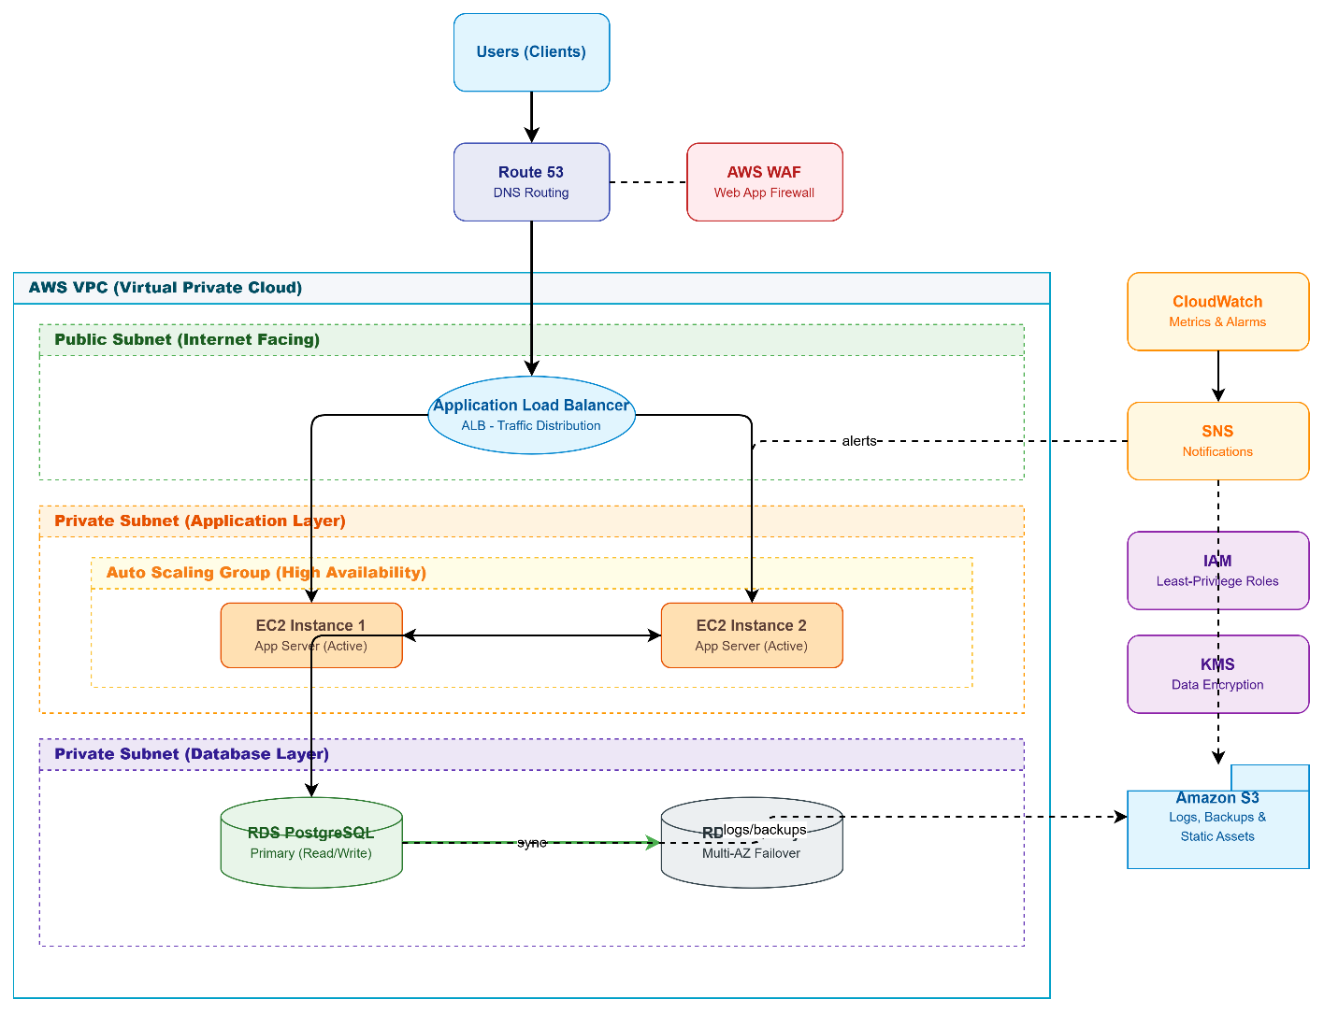

AWS Three-Tier Web Application Architecture – Step-by-Step Flow
- Users (clients) send requests over the internet to access the web application.
- AWS WAF (Web Application Firewall) inspects incoming traffic and blocks malicious requests before they reach the DNS layer.
- Route 53 receives the request and performs DNS routing, directing traffic to the correct endpoint.
- The request enters the AWS VPC (Virtual Private Cloud) through the Public Subnet, which is internet-facing.
- The Application Load Balancer (ALB) in the public subnet receives the traffic and distributes it across healthy backend servers.
- The ALB forwards traffic into the Private Subnet (Application Layer), where the Auto Scaling Group manages application servers for high availability.
- The Auto Scaling Group runs two EC2 instances (EC2 Instance 1 and EC2 Instance 2), both active app servers that scale automatically based on demand.
- EC2 instances process the application logic and connect to the database layer in the Private Subnet (Database Layer).
- The RDS PostgreSQL Primary instance handles all read/write database operations.
- The RDS Standby instance, configured in Multi-AZ mode, continuously syncs with the primary database to provide automatic failover in case of failure.
- Logs, backups, and static assets generated by the application and database are stored in Amazon S3.
- CloudWatch continuously monitors metrics and triggers alarms based on performance or error thresholds across EC2, RDS, and ALB.
- When an alarm is triggered, CloudWatch sends a notification to SNS (Simple Notification Service).
- SNS notifies administrators and can also trigger automated actions, such as scaling adjustments or alerts to the EC2 instances.
- IAM (Identity and Access Management) enforces least-privilege roles, ensuring each AWS service and user has only the permissions necessary to perform its function.
- KMS (Key Management Service) encrypts data at rest and in transit across S3, RDS, and other services to maintain data security and compliance.

